Sonarqube Lab

Q1: Install sonarqube with helm:

I have pulled sonarqube repo from github , then I ran the command ->

helm install sonarqube sonarqube

the output is down below ->

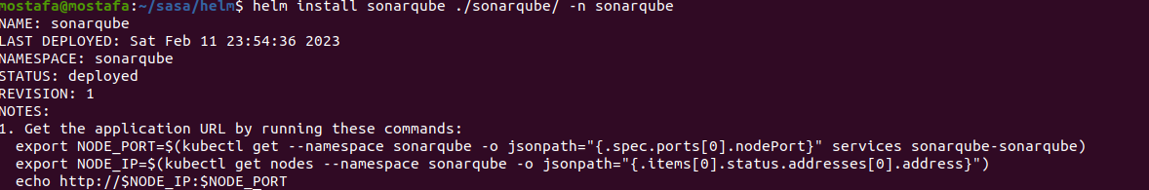

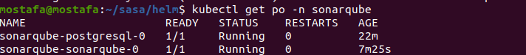

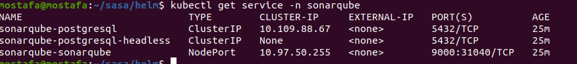

here is the login page :

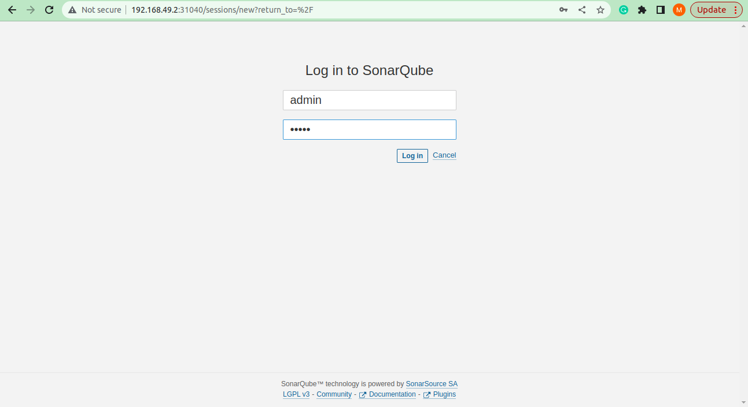

Q2: Integrate sonarqube with Jenkins:

